****\*\*4



**Read To Ride**

**Dependable Cleaners is raffling off one bike every week from May 16-August 12.**

Children between the ages of 6 and 15 can participate in Read to Ride by reading books and filling out entry forms for each book they read.  Completed entry forms can be dropped off at any Dependable Cleaners location.  The closest locations are in Milton and Dorchester. Entry forms can be picked up at any [Dependable Cleaners](http://www.dependablecleaners.com/locations) and they were also sent home with your child.  You can also download it at: [www.dependablecleaners.com/read-ride](http://www.dependablecleaners.com/read-ride). The more books your child reads the more chances they have to win!  Each entry form will be entered into a drawing to win a brand new bike. Drawings will take place every Monday beginning May 16th until Aug 12th, 2016.

**The core value for this month is**

**”Courage”**

**Finding strength in the face of pain or grief.**

**A Note from the Principal…**

May Greetings from the Roosevelt! This is a very busy time of year! Our students in grades three through eight are participating in the PARCC testing through June 3rd.  We also have many field trips, activities and events planned through the end of the year. The Debate Mate Team, and Robotics Club, sports teams and BOKS are all finishing up for the year.

Thank you to all who have provided these opportunities for our students.

Look for the June 1st calendar for all the important end of the year activities!

**Franklin Roosevelt School**

**Big Time News May 18, 2016**



**Big Time News**

**May 4, 2016**

**K -1 update**

The K1 team has moved into our Things that Grow unit! We are excited to watch our caterpillars and ladybug larvae grow and see the whole life cycle! In connection to our unit, we are also growing grass and beans in the classroom. We also look forward to planting in the new outdoor classroom. The K1 classrooms will be taking a trip to NRT (Natural Resource Trust) in Easton, MA to explore bugs and nature. This unit is filled with lots of hands on learning opportunity.

**Save the Date**

**Spring Music/Art Show June 14, @ Lower Campus**

**5:30 – 7:30 pm**

Come see your child for a fun night! Each class will sing a song and there art will be on display throughout the building.

https://ssl.gstatic.com/ui/v1/icons/mail/images/cleardot.gif

**Fun Friday at Lower Campus:**

**Represent Your Room Color Day**

**Friday, May 27th**

Our last Fun Friday is on May 27th…Represent Your Room Color Day! The children are invited/encouraged to show their room color spirit on that day! We will take our annual rainbow picture outside and have a small parade on the playground. Families are welcome to join us at 1:35 pm that day!

$1.00 donation goes directly back to Lower Campus field trip funds.

**SPC CORNER:**

**SAVE THE DATE for FIELD DAY 2016:**

Lower Campus Friday June 10th

Upper Campus Thursday June 16th

We will be looking for **parent volunteers** at both campuses.  We need your help to make this a success!!!  There will be sign ups available thru Facebook page by the beginning of next week and sign-up sheets will also go home next week.  More details to come!!!!

Any questions or concerns please contact one of the co-chairs: Pam Bellamy [blish3939@hotmail.com](mailto:blish3939@hotmail.com) or Jayme Washington at  [jayme@wpaboston.com](mailto:jayme@wpaboston.com)

https://ssl.gstatic.com/ui/v1/icons/mail/images/cleardot.gif

**Max Warburg Awards**

**Shout out** to Lael and Erin and all the other teachers who have taught Natalie Trapanick and Maureen Baumiller. These two ladies were honored at the Max Warburg Luncheon yesterday at the Copy Plaza. Their award winning essays on courage are in the Annual Essays in Courage book and you can stop by my office to read it if you would like.

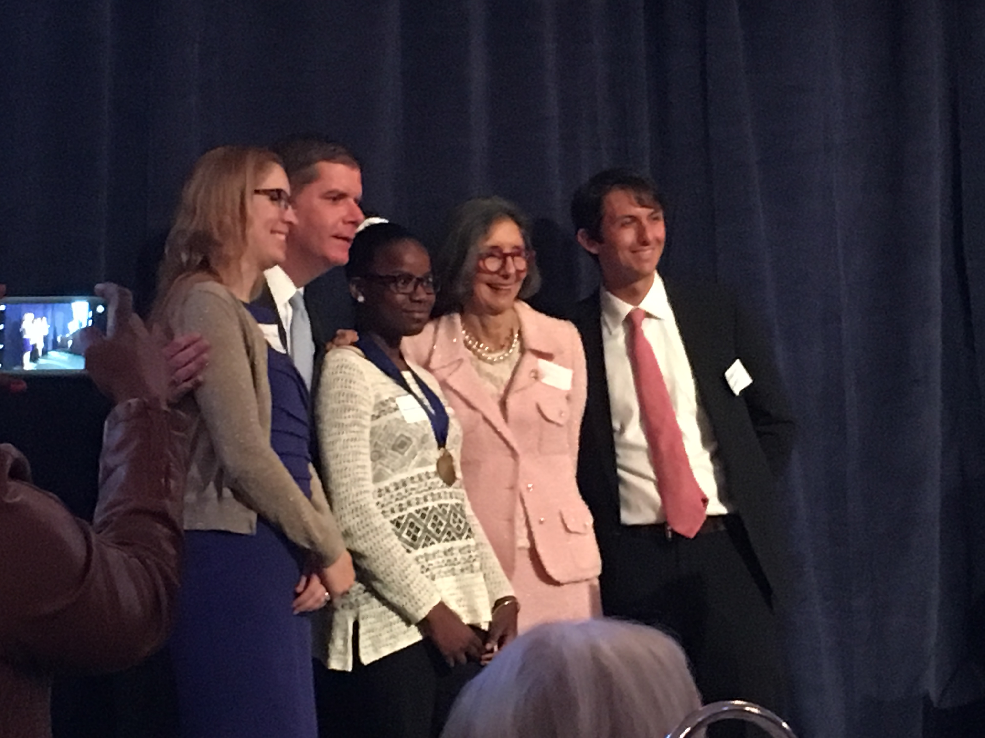 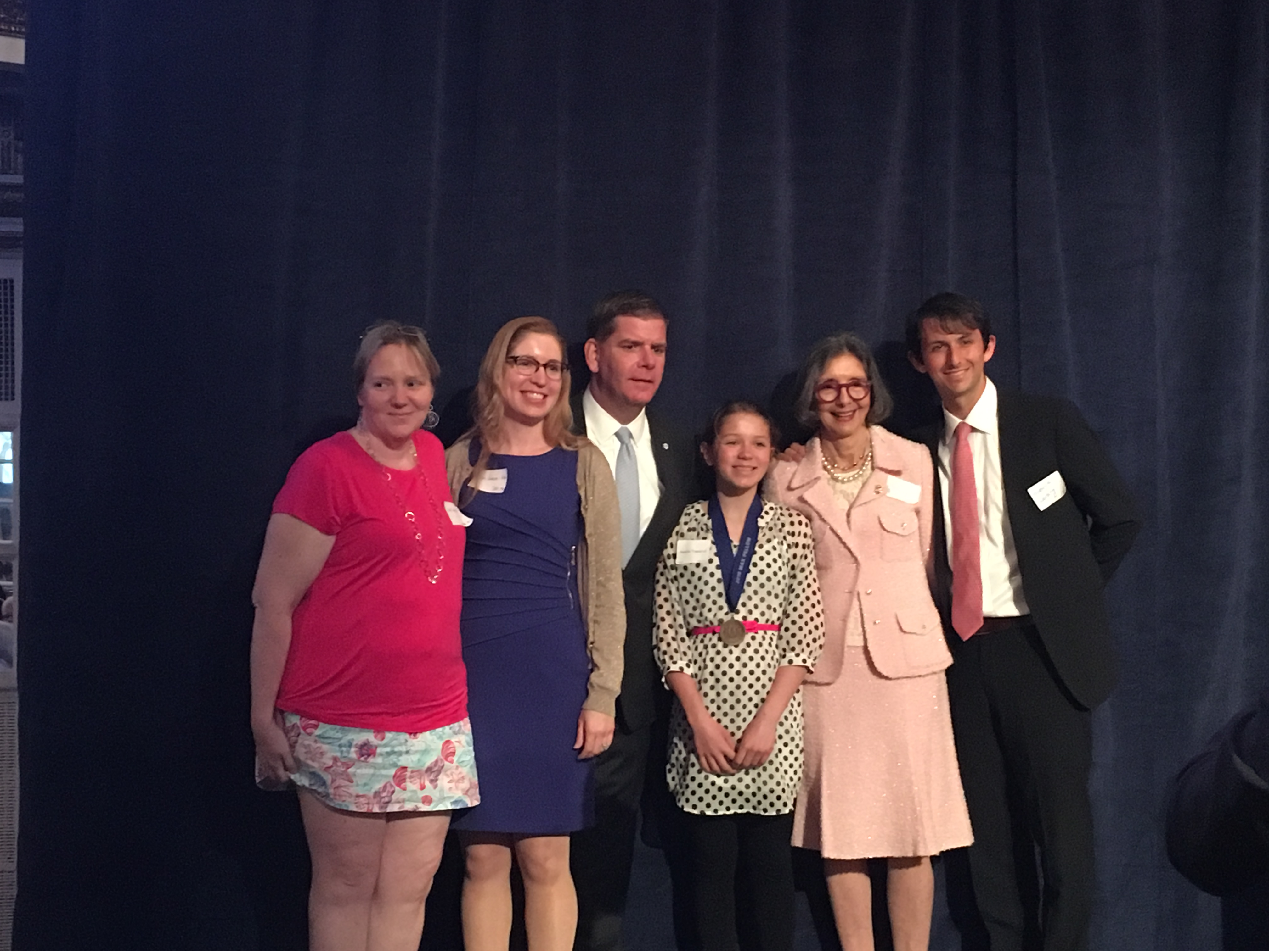

**7th Grade News**

In Ms. Beaulieu's 7th grade ELA classes, students are currently learning about the time period of Segregation in our country centering ar*-ound the events of the death of Emmett Till through the shared class novel titled, Mississippi Trial, 1955 by Chris Crowe.  In the 8th grade classes, students are learning about the Jewish Holocaust through the shared class novel titled, Daniel's Story by Carol Matas.  Both grades have engaged in very thoughtful discussions as they learn about teens that must make tough decisions, and deal with extreme conflicts in as a result of the settings in both novels.

**Tech Corner**

**Dance Mat Typing**

<http://www.bbc.co.uk/schools/typing/flash>

Work your way through 12 stages to learn how to type!  This is a fun and engaging way to learn keyboarding skills.

c

# 

**Drama Club**

"On Saturday, April 30th the Middle School Drama Club competed in the Massachusetts Middle School Drama Festival hosted by the Massachusetts Educational Theatre Guild. Over 40 middle schools in Massachusetts perform in this annual festival. The FDR Drama Club received a Bronze medal for their performance of the one-act play "The Dancers". The competition was held at the Bromfield School in Harvard, MA."

**Outdoor Classroom News**

We are so excited here at Lower to use our outdoor classroom! Each classroom has a raised bed out back for planting and growing. The classrooms also got ladybug larvae and caterpillars to observe the life cycle of ladybugs and butterflies happen before our eyes! There is lots of hands on learning happening....we are looking forward to wonderful learning experiences.

*\*\*\*\*We ask that families help us in having the children use our outdoor space kindly. Friendly reminder…the stumps are for sitting not standing or jumping; we want to ensure the safety of all of our students.\*\*\*\**

**Lower Campus Field Trip to the Blue Hills**

On Friday, June 3rd the Lower Campus will be taking a trip, in connection to our outdoor classroom, to the Blue Hills. The children will enjoy observing the animals, a picnic lunch and a nice hike.

**Memorial Day**



**Monday, May 30 No School**

**Franklin D. Roosevelt School**

**Principal Lynda-Lee Sheridan**

**Assistant Principal Bannet Steele**

**Upper Campus**: 95 Needham Road, Hyde Park, MA 02136

P: 617-635-8676

F: 617-635-8679

**Lower Campus**: 30 Millstone Road, Hyde Park, MA 02136

P: 617-635-9280

F: 617-635-9284

Please visit our website at **bostonpublicschools.org/roosevelt**

to find all general information about the school and classroom web

**PARCC (testing dates)**

|  |  |
| --- | --- |
| **GRADE 6** |  |
| ELA | May 20 |
|  |  |
| **GRADE 7** |  |
|  |  |
| Math | May 31, June 1, 2 |
| **GRADE 8** |  |
|  |  |
| Math | May 23, 24, 25 |